*Objective*

The objective of our project is to create an online examination system that facilitates instructors with a straight-forward but robust utility to conduct virtual assessments.

*Requirements***Actors**

1. User
2. Student
3. Instructor
4. System

**Functional Requirements**

1. The user shall be able to sign into the system.
2. The user should be able to upload a profile picture.
3. The system shall display the student’s examination schedule.
4. The system shall automatically grade multiple choice questions
5. The system shall calculate the mean, median, and average of each assessment.
6. The system shall close the assessment once the time limit has been reached.
7. The system shall submit any selected questions once the time limit has been reached.
8. The student shall be able to see grades and feedback of their previous assessments.
9. The student shall be able to see statistics about their assessments.
10. The student shall see the percentage of each question from the total assessment marks
11. The student shall be able to see the solution key once the assessment has ended.
12. The student should be able to view the instructors contact information.
13. The instructor shall be able to create a multiple choice question.
14. The instructor shall be able to create a short answer question.
15. The instructor shall be able to create a True or False question.
16. The instructor shall be able to set the time limit for an assessment.
17. The instructor shall be able to see the grades of each student in the examination.
18. The instructor shall see all possible statistics (mean, median, standard deviation) of the assessments.
19. The instructor shall be able to provide feedback for each question in the exam.
20. The instructor shall be able to provide feedback for the overall grade in the exam.
21. The instructor shall be able to assign varying points to each question.
22. The instructor shall be able to randomize the order of the questions displayed.
23. The instructor shall provide a file that contains a formula sheet or cheat sheet if necessary
24. The instructor shall be able to add images to questions.
25. The instructor should be able to material references to each question.
26. The instructor should be able to reuse question banks.
27. The instructor shall be able to add practice questions for each assessment.

**Non-Functional Requirements**

1. The system shall be decomposed into different parts categorized by functionality.
2. The prototype shall be implemented using Adobe XD.
3. The system’s user interface shall be responsive on all platforms.
4. The system shall not be shut down for maintenance for more than once in a 24-hour period.
5. Function calls shall not be nested more than three levels deep.
6. The system shall be developed to adhere to HTML guidelines and standards.
7. Passwords shall never be viewable at the point of entry.
8. The system shall be able to handle more than 200 simultaneous users at a given time.
9. The system shall have a maximum response time of 4 seconds.

*Similar Online Examination Systems*

1. [eSystem](http://www.speedwellsoftware.com/)
   * Create, administer, analyze examinations.
   * Allows students to take the exam offline.
   * Automated grading & feedback.
   * Question bank allows randomization of questions supplied to each student

1. [Eklavvy](https://www.eklavvya.in/)
   * Available on all platforms
   * Systematic Analysis with ranking, percentile, topic wise analysis, question wise analysis and batch performance analytics
   * Question Bank Management System with objective, subjective, multiple choice, fill in the blanks, image, audio and video based questions
   * Face Recognition to control Remote Exam Sessions
   * Allows sharing artifacts with students

1. [Mettl](https://mettl.com/en-ae/computer-based-tests/online-exam-software/)
   * Allows 26 different types of questions formatting including complex mathematical and chemical equations as well as complex scientific diagrams
   * AI-based proctoring with 95% accuracy in cheating detection
   * Recorded monitoring of exams
   * Verification of examination candidate through OTP, email and ID proof
   * Custom secure browser that prevents students from accessing other softwares
2. [TestInvite](https://www.testinvite.com/)
   * Webcam recording of students throughout the examination
   * Questions can be mapped to learning outcomes, subjects or personality traits
   * Custom secure browser that prevents students from accessing other softwares
   * Questions can be classified systematically by assigning multiple tags such as difficulty level
   * Auto evaluation rule to allow grading of open ended questions using regular expressions
3. [ProProfs](https://www.proprofs.com/quiz-school/)
   * Available on all platforms
   * Useful insights with advanced reports and statistics.
   * Automated grading & feedback.
   * Question bank with 6 different types of question formats including multiple choice and short answer questions.
   * Quizzes can be shared through social media, links, emails and can be embedded in websites as well.

*Use Case Diagram*

*Wireframes***General View**

* Sign In Page

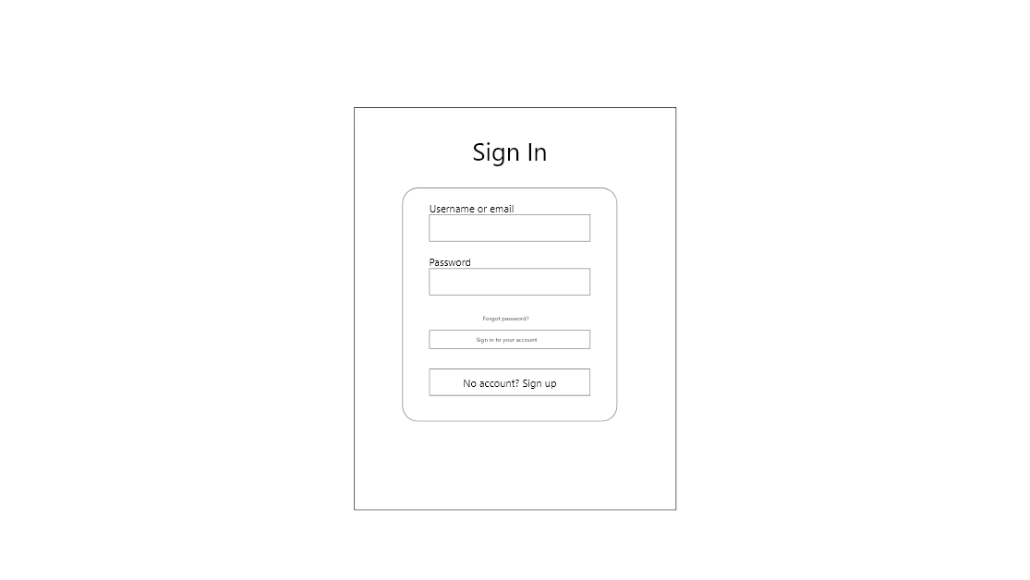

* Sign Up Page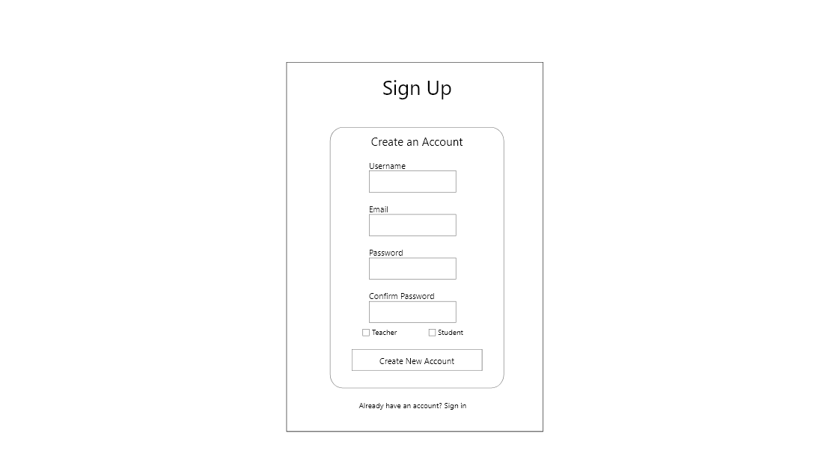
* Profile Page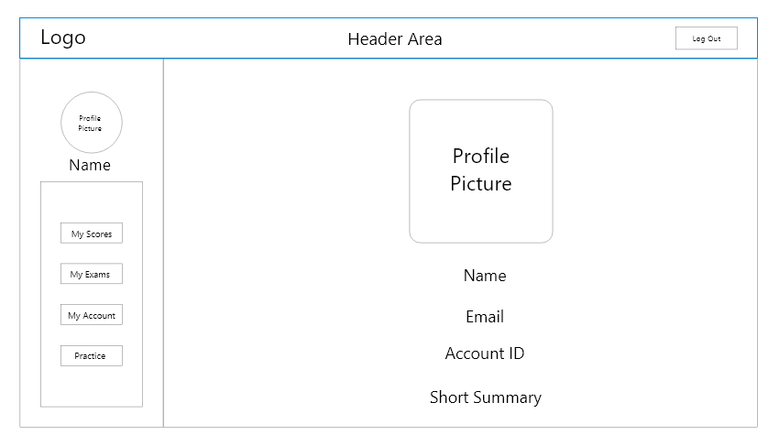

**Student View**

* Student Home Page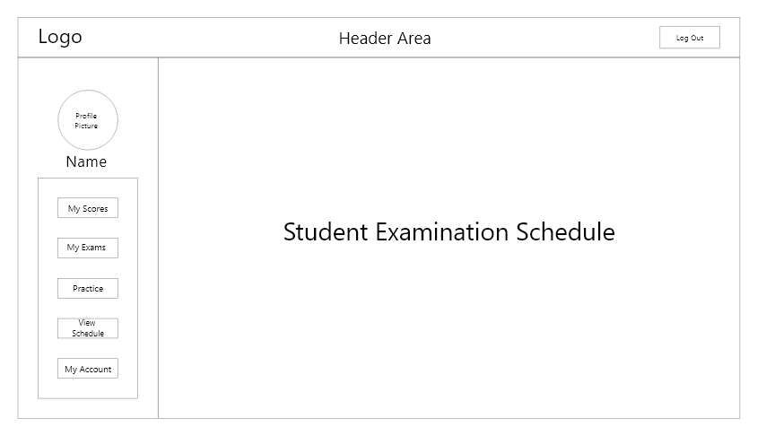
* Student: My Scores Page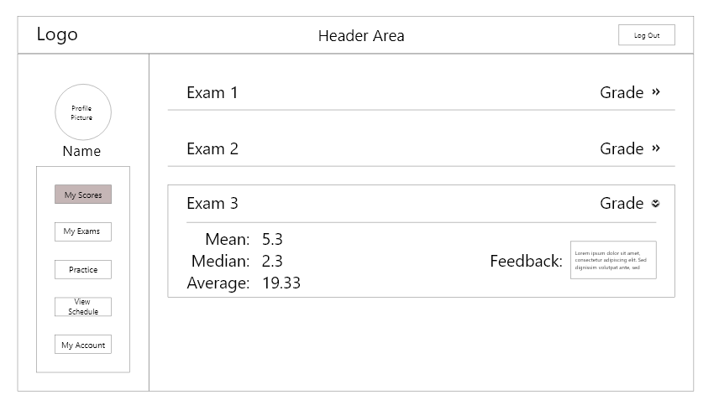
* Student: My Exams Page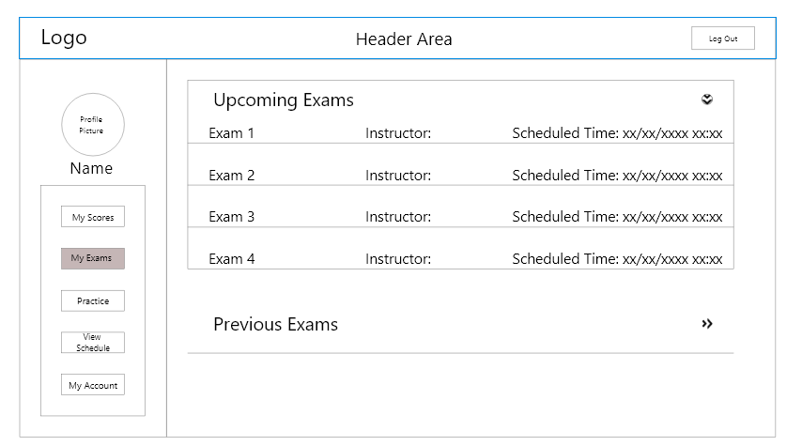
* Student: Exam Start Page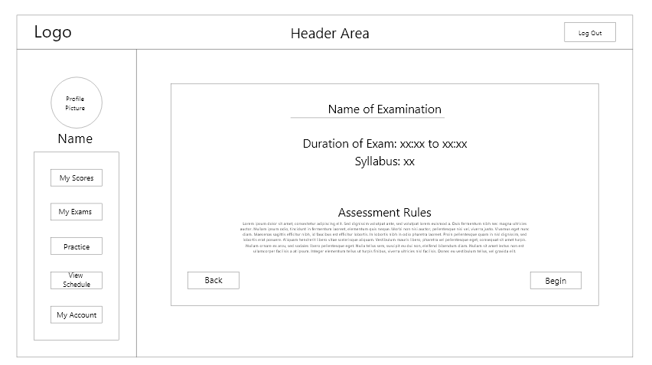
* Student: Exam Question Page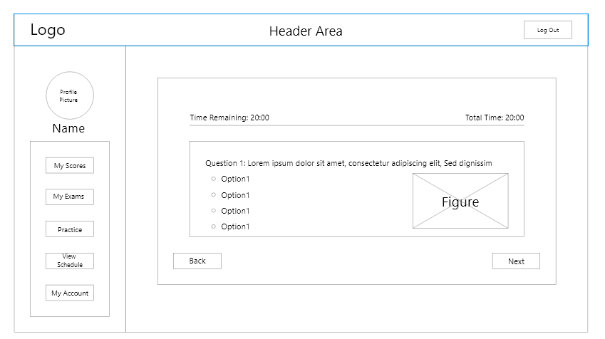
* Student: Practice Page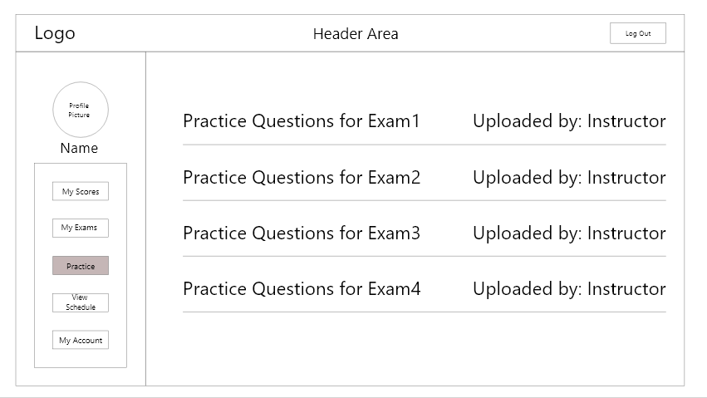
* Student: Practice Questions Page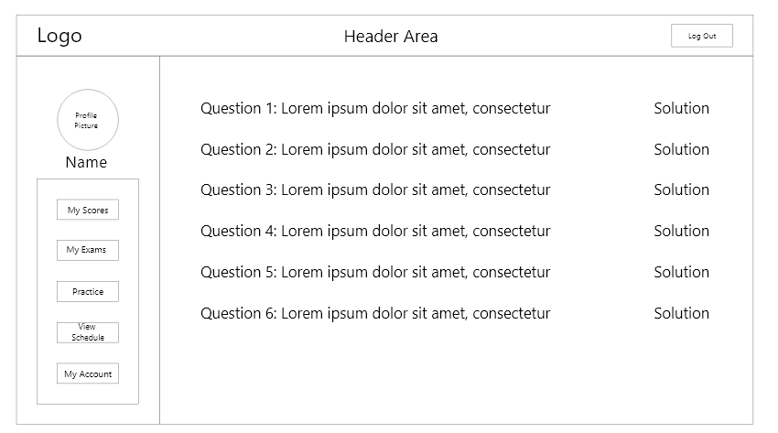

**Instructor View**

* Instructor: Home Page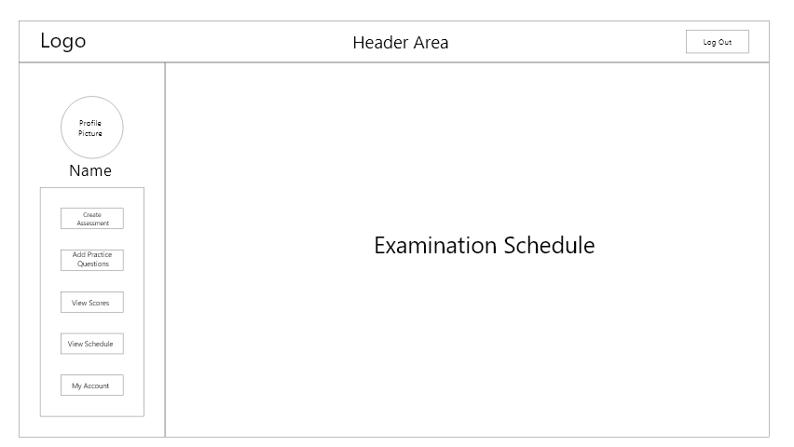
* Instructor: Create Assessment Page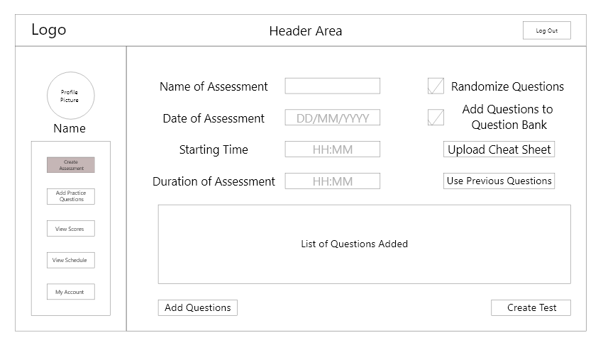
* A screenshot of a social media post

  Description automatically generatedInstructor: Add Practice Questions Page
* Instructor: Add Questions to Test Page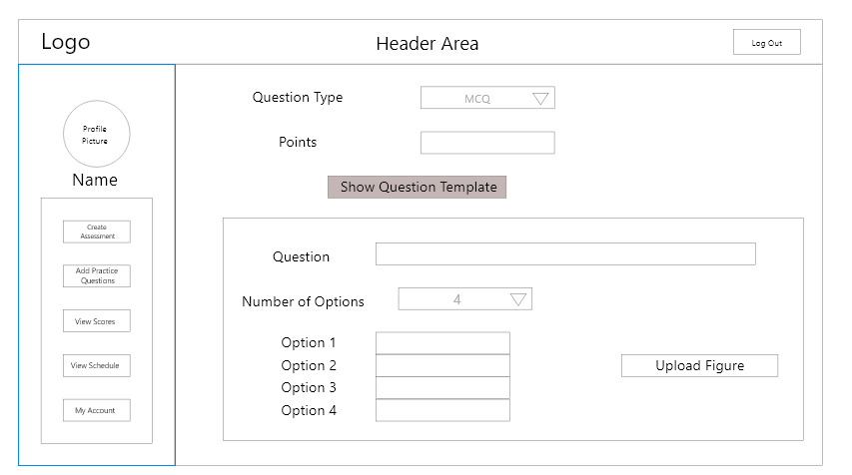
* Instructor: View Scores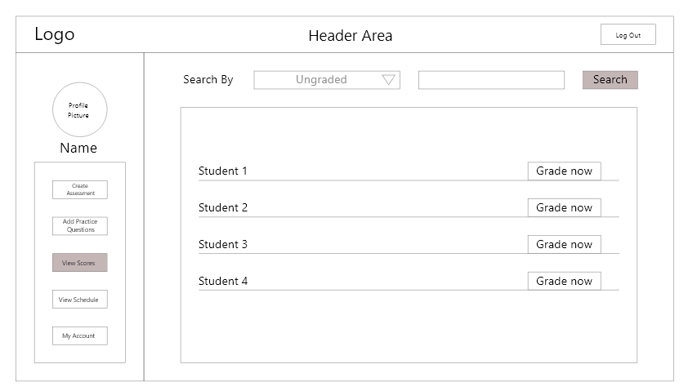
* Instructor: Grading Page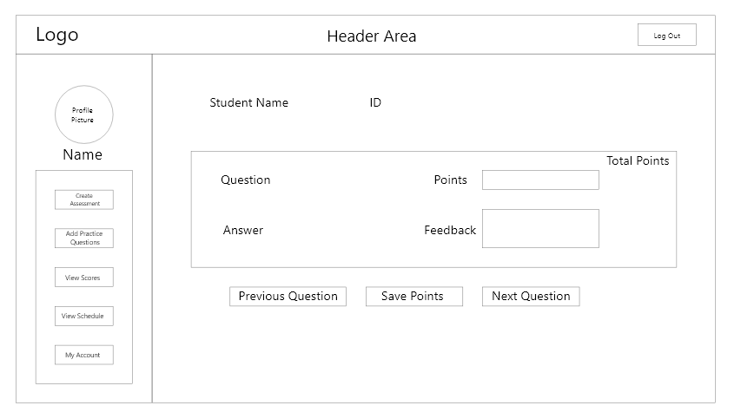

*Prototypes***General View**

* Sign In Page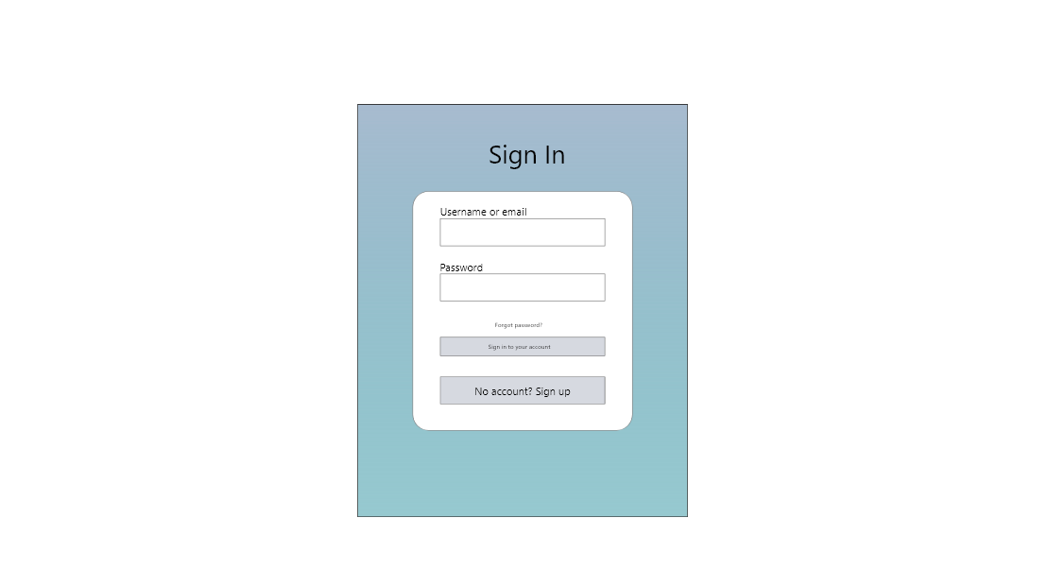
* Sign Up Page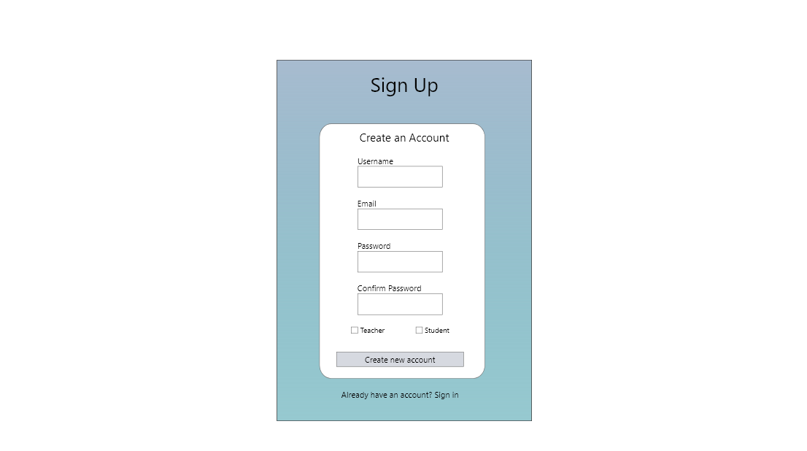
* Profile Page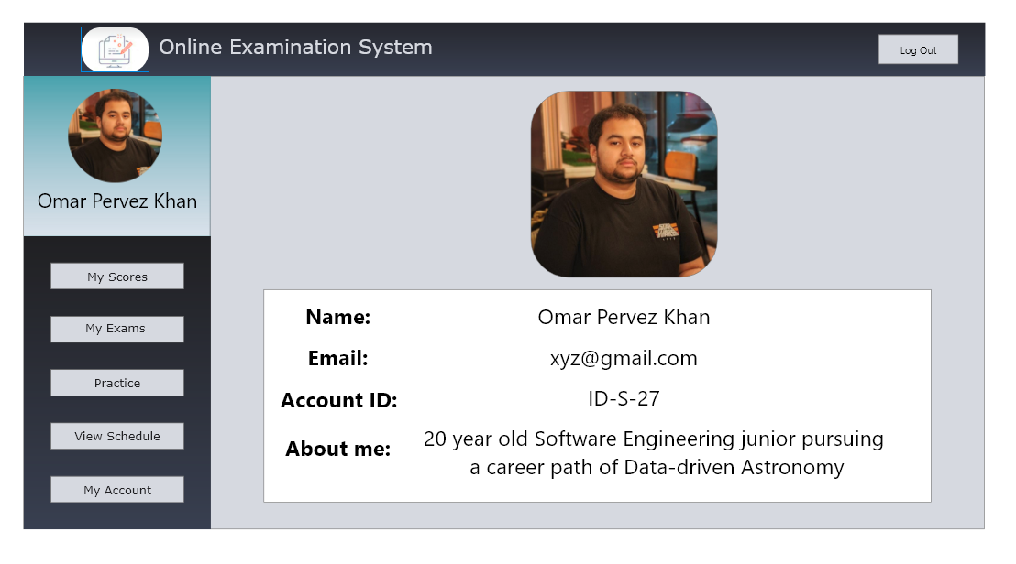

**Student View**

* Student: Home Page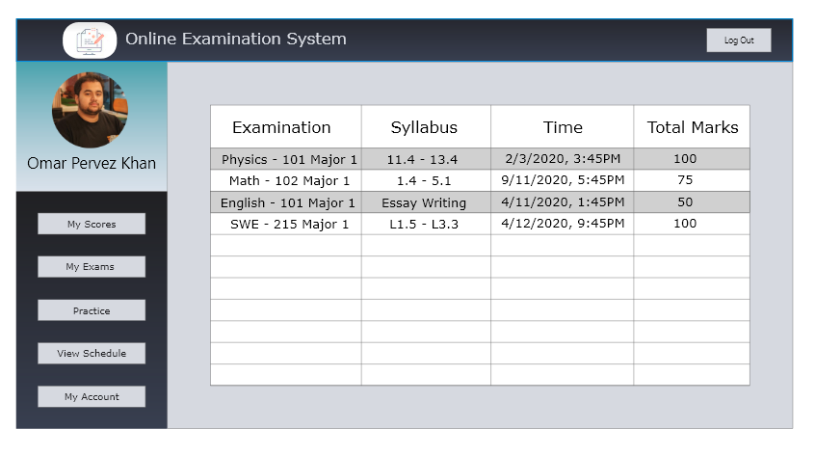
* Student: My Scores Page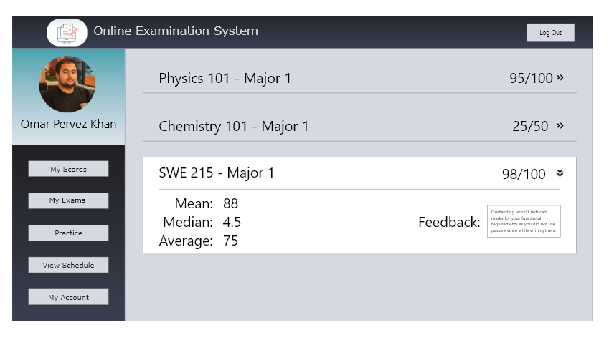
* Student: My Exams Page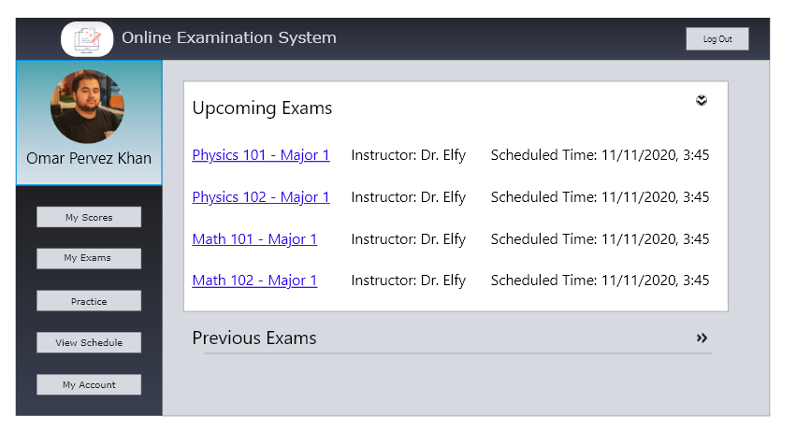
* Student: Exams Start Page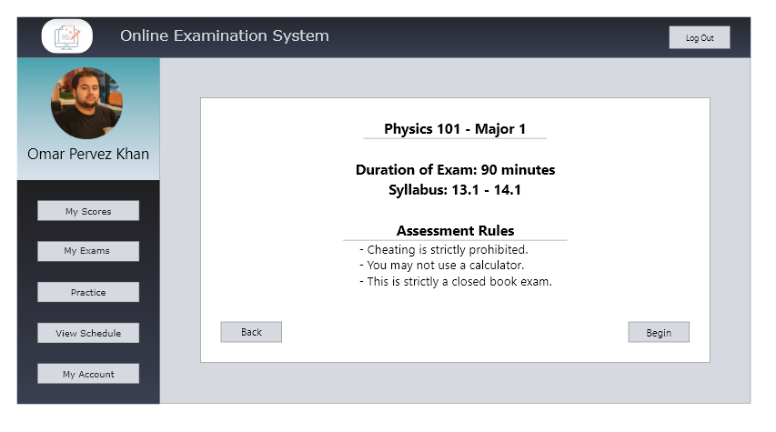
* Student: Exam Question Page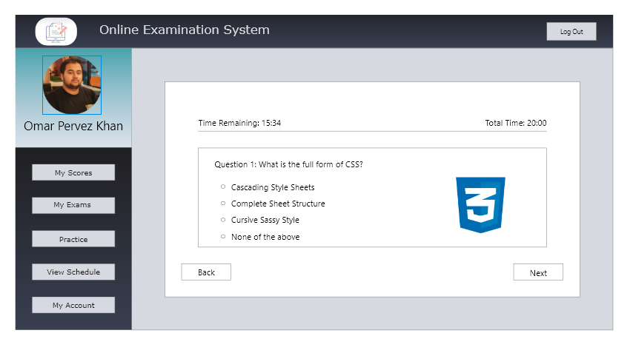
* Student: Practice Page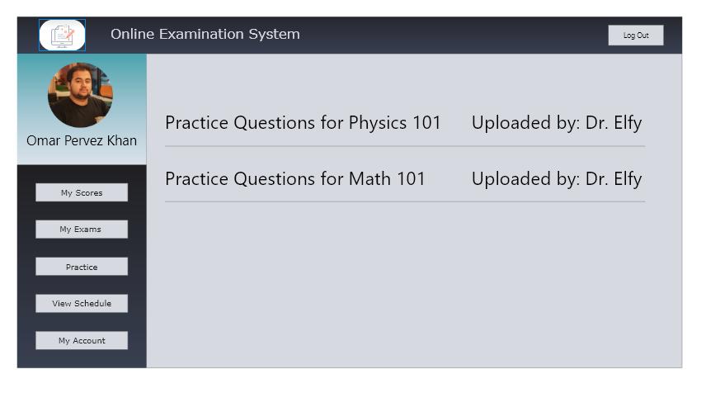
* Student: Practice Questions Page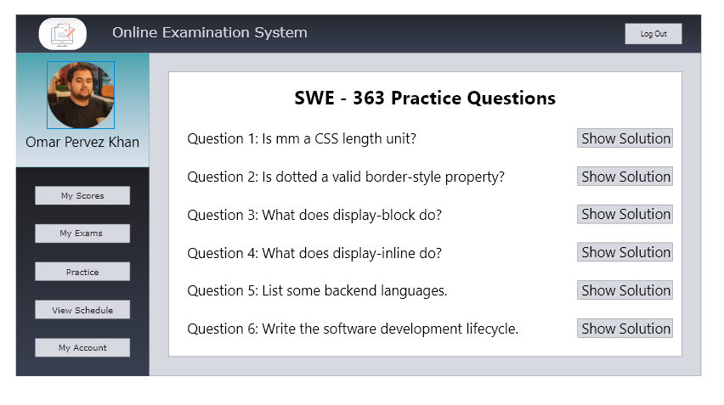

**Instructor View**

* Instructor: Home Page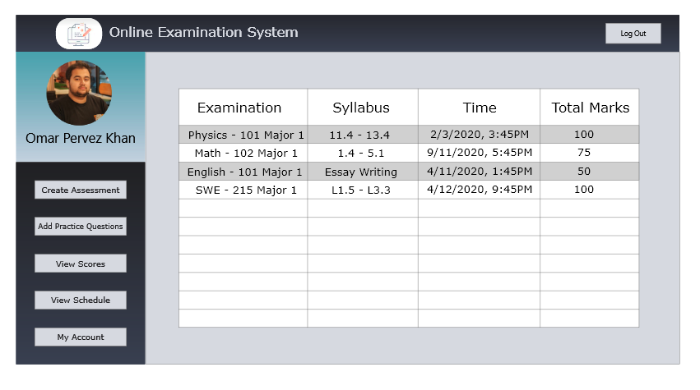
* Instructor: Create Assessment Page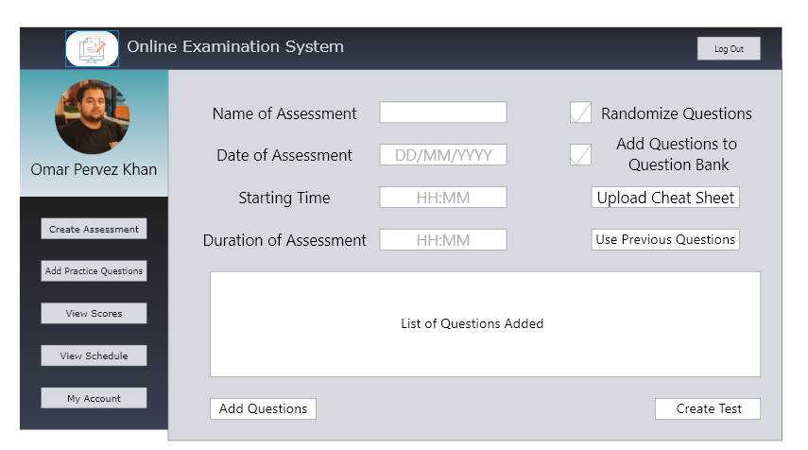
* Instructor: Add Practice Questions Page:

* Instructor: Add Question to Test Page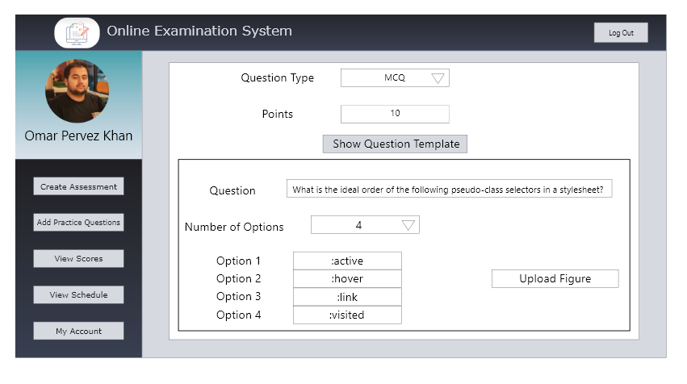
* Instructor: View Scores Page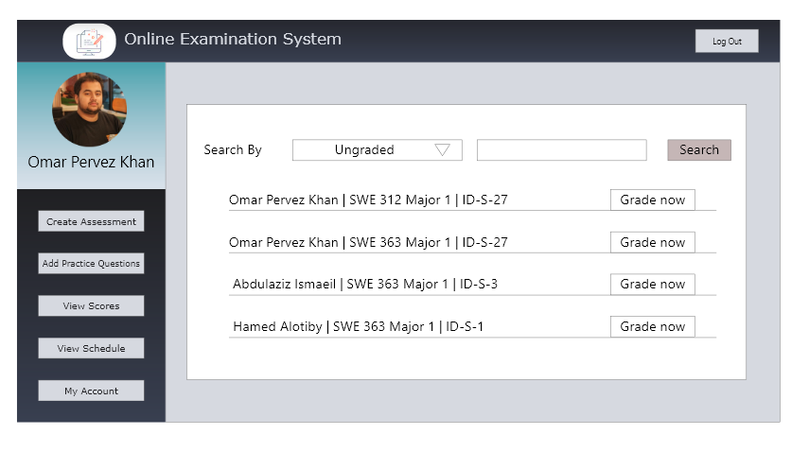
* Instructor: Grading Page